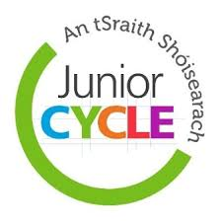  Wed 15th Nov at 7.30pm  Junior Cycle Framework Information Meeting  An important Information Meeting has been scheduled for Wednesday 15th November at 7.30pm. This is for parents and guardians of first and second year students who are all taking subjects – some between three and seven – as part of the new Junior Cycle Framework.  Audrey Doyle from JCT (Junior Cycle for Teachers) will present on the new framework and answer any questions that you might have. | Junior Cycle Information Session for Parents and Guardians  ────  Wednesday 15th November at 7.30pm in the Choir Hall  ────  Audrey Doyle from JCT will present on the New Framework  All 1st and 2nd Year Parents and Guardians are invited and encouraged to attend  ────  Wed 15th Nov at 7.30pm

